When we have a loop statement, that loops through our internal table that uses a work area. The loop reads each record from our internal table, into the work area instead of the header line.

Now because we can specify the work area separate to our internal table, we must specify that work area we want to use within our loop to read the data into.

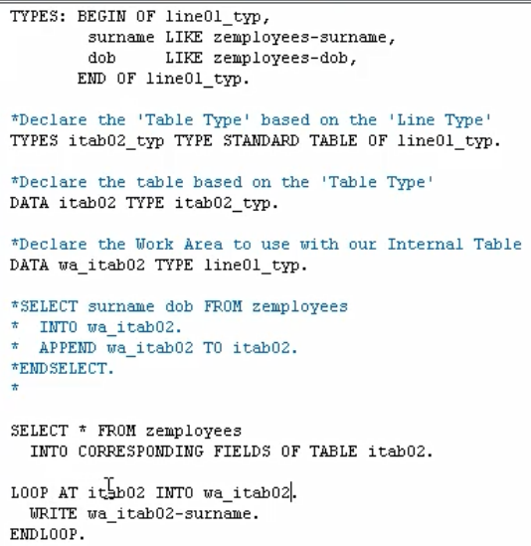

the standard loop statement, we're looping our internal table but we're going to instead of using the hex line, we're going to read our records into how our own predefined work area. And then when we want to work with any data that belongs to the work area, we reference the work area directly. So, our write statement says WRITE the surname field from our work area, not the internal table.